# of samples tested | # of samples with detectable insecticides | % of samples with detectable insecticides
632 | 84 | 13.29%
# of non-mig samples tested | # of non-mig samples with detectable fungicides | % of non-mig samples with detectable fungicides
442 | 47 | 10.63%
Herbicides Analysis

(Method: summary stats)
2010-2013 | n | Mean | St. Dev | Min | Max | Percent infected at detectable level | Percent infected at threshold level | t-stat | p-value
Mites per 100 bees (Insecticides) | 67 | 2.75 | 4.06 | 0 | 26.28 | 82.09% | 25.37% | -3.67*** | 0.00
Mites per 100 bees (No insecticides) | 508 | 5.51 | 5.98 | 0 | 37.16 | 92.52% | 56.30% | -3.67*** | 0.00
Nosema per bee (Insecticides) | 66 | 0.47 | 1.17 | 0 | 7.95 | 57.58% | 13.64% | 1.16 | 0.25
Nosema per bee (No insecticides) | 507 | 0.34 | 0.85 | 0 | 10.8 | 47.53% | 11.24% | 1.16 | 0.25

Morbidity Summary Statistics (migratory + non-migratory)

(Method: Basic t-stats)

Cropscape

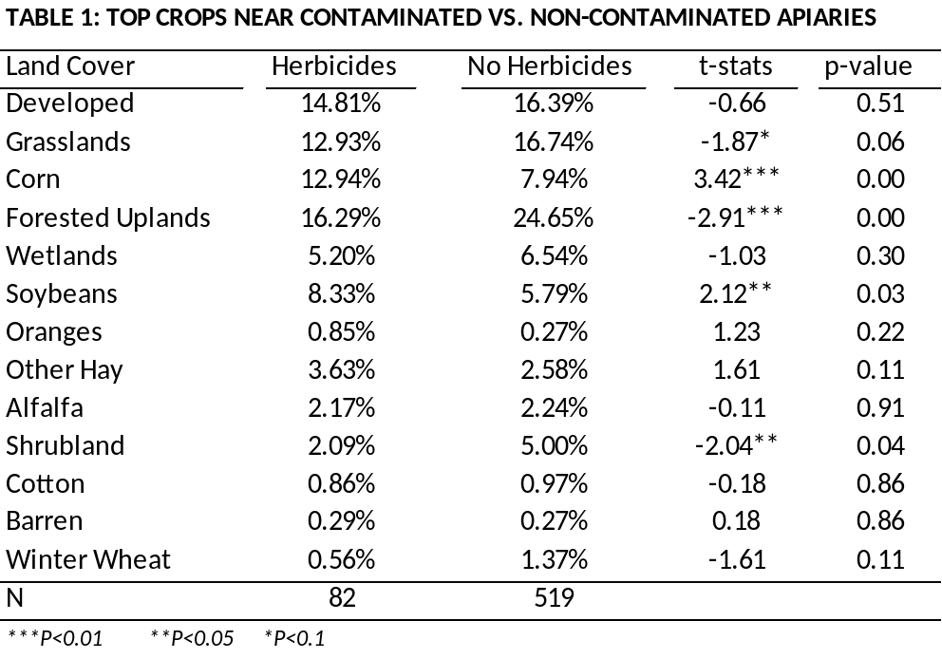

Detection Time and Location
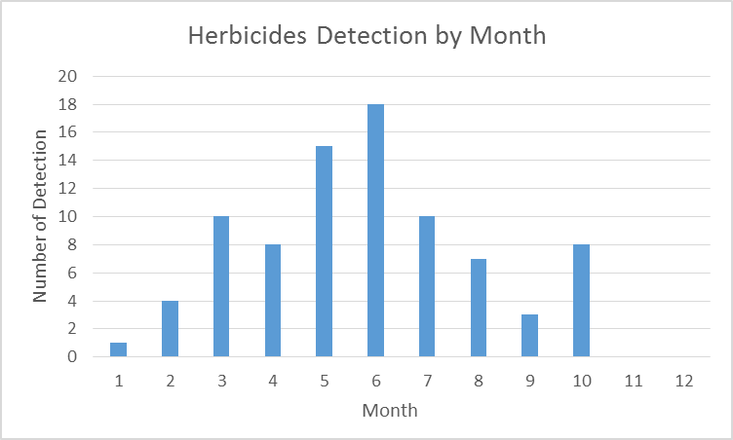
Month | Count
Jan | 1
Feb | 4
Mar | 10
Apr | 8
May | 15
Jun | 18
Jul | 10
Aug | 7
Sep | 3
Oct | 8
Nov | 0
n=84

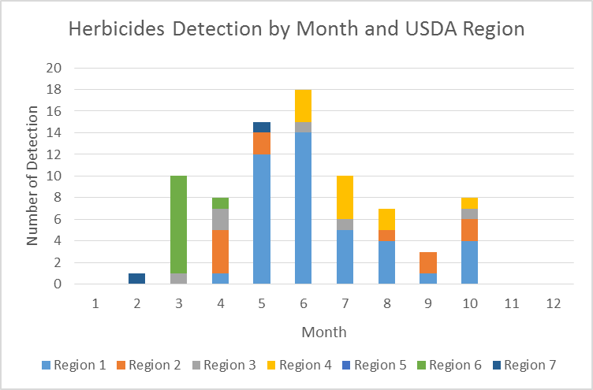
The detection of herbicides also follows the trend for other pesticides (warm regions like CA and FL, then move to the Midwest, then to cooler places in NY and NJ)….I wonder whether this is because samples we have are representative that way (or in other words, whether we do have more samples in CA during the early months)

